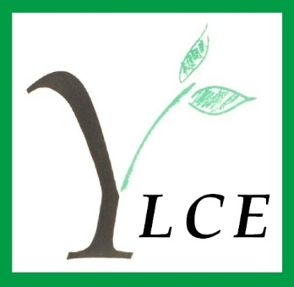

Autumn Update 2015

Dear Fellow Members
The jams are on the shelves and plums, berries and rhubarb are in the freezer ready for the winter pies and crumbles requested by weekending children and grandchildren. It’s the time for all the social and learning opportunities that so enliven the colder and darker months to begin.
Already the Awards Committee have considered 71 applications and given 26 grants to deserving students. The Executive Committee has continued its work on Good Governance and on defining the core concerns of the Yorkshire Ladies as a whole, the Projects Committee will build on the success of its Internet Safety Study Day in July with further attention to ways YLCE can help with the protection of youngsters online and the Social Committee is planning a wonderful Sandwich Lunch and Christmas Fair for you on November 5th at St Chad’s. Among the stalls at this event will be the usual array of delicious fresh food ready for you to freeze or shelve for the festive season as well as cards, books and CDs, a raffle, handbags and scarves and other good things. I’ll be there and I am looking forward to seeing you there too.
Obviously I will still be around but this is my final letter to you as I will be retiring as Chairman at the 2016 AGM. I want you to know how much I have appreciated all your support and your friendship over the years. Your kindness (a much underrated virtue) and help have meant a great deal to me. Thank you.
With great gratitude and warmest best wishes to you all.

Nancy Donner
Chairman

PROJECTS COMMITTEE

This past year the Projects’ Committee has continued to support The Inside Outside Club, St Gregory’s, Seacroft, which is in one of the most deprived areas of Leeds. Inside Outside Childcare offers valuable educational and practical support for children of school age as well as their parents. This year it was confirmed that the money raised at our annual fundraising Coffee Morning in March would be used to fund an additional needs worker to work an extra five hours per week for fourteen weeks.
We look forward to our next Coffee Morning which is to take place on Thursday 17th March 2016 at St Chad’s Parish Centre, Otley Road, Headingley, Please mark the date in your diary and come and support us! Not only is it a pleasant social occasion and a perfect opportunity to shop for gifts and plants, but it is the committee’s main fundraising event of the year.
In a departure from our usual activities, The Projects’ Committee hosted a study afternoon in July at Forest Hill when members and guests gathered for a presentation given by Claire Dodd of Leeds City Council about the problems posed by internet pornography and the dangers of grooming by sexual predators on children and young people. It was a stimulating and thought-provoking event and we extend our thanks to Claire Dodd and to our committee member Kathy Hart, who organised and co-ordinated the afternoon, as well as to members of the Social Committee who provided refreshments for the afternoon.
We are in the early stages of considering holding another such event as many YLCE members who were unable to be with us in July, have expressed an interest in attending. Please give the idea consideration as it is an issue which, one way or another will affect most of us, if not directly, certainly via our families and friends.

Margaret Pullan

FUNDRAISING COMMITTEE

Mrs Elizabeth Peacock has now stepped down as Chairman of the Fundraising Committee and we are looking for a new Chairman. The purpose of the role is to raise funds for the YLCE. This can be achieved by accessing available funds from larger organisations, forming partnerships with appropriate bodies or maximising one off opportunities that may arise. It is a fairly broad remit and is a vital function of YLCE. If you are interested in either being Chairman of this Committee or being part of the Committee in general, please contact Nancy Donner.

AWARDS COMMITTEE

Our June meeting was a sad occasion: we were saying goodbye to Isobel. After taking over from Jillian Rennie in March 2010, Isobel Jenkins managed the Affairs of the Awards Committee with consummate skill and dedication. Her calm efficiency in the chair ensured that meetings, despite their sometimes intense nature, were always pleasant and satisfying occasions. We’ll just have to manage without her wisdom and experience, I suppose. It does comfort me though, to know that her advice and guidance are there at the end of a telephone line when needed. In September we were pleased to welcome to the Committee Mrs Alison Harris whose wealth of experience in all aspects of education will stand us in good stead in our future deliberations.
Since the last Newsletter your Awards Committee has been working hard, of course. What else would you expect? In June and September we scrutinised with great care and respect requests for support from more than two hundred women. With a small purse at our disposal we were able to grant awards to thirty-eight women, having to reject one hundred and sixty-three applicants. The average award remains at £300. We made some difficult decisions, as you can imagine. And we wish our purse held a lot more money.
How do we choose which applications to look on favourably? Some we can dismiss quickly as “pie in the sky”: from those women who don’t have a hope of raising enough money to cover their fees and are totally unrealistic in their expectations. Some foolishly write that Granddad or parents or rich Uncle Leopold will pay their fees: but we grant money to help with course fees only, so these have already ruled themselves out. Then there are some who clearly have a lot of family financial support, went to fee-paying schools even, but still have money to find on order to pay the huge fees that universities are demanding. In these cases we guess that parents will find the extra at a pinch, but have told their daughters to do their best to raise the money themselves. There are so many women in situations more deserving of our help: applicants with working class backgrounds with no family support; single bereaved mothers needing to upgrade their qualifications in order to get a better-paid job to support their families; women whose part-time jobs have been severely cut, so that their carefully planned budget is suddenly meaningless or whose promised sponsorships were simply withdrawn when a business ran into financial difficulties, women whose unexpected health problems have robbed them of their savings.
We demand of our applicants that they put their case for funding convincingly.
Amongst those who did so this summer is a young mathematician about to begin a Masters in Information Security, planning a rewarding (and important) career in the cyber security industry. We’re also supporting an artist about to study theatre and film property-making at RADA (and are expecting some theatre tickets eventually), and we made an award to a neuroscientist whose own experience of post traumatic stress prompted an academic desire to research how the brain reacts in such cases.
And, as you know, many of our award recipients keep us up-to-date with news of their studies and careers. One student, now a qualified veterinary surgeon, whom we’ve been able to support over the last three years, writes that the help we give is more than just financial; she expresses her appreciation of the fact that we believed in her potential and that in times of exhaustion and tears during the course the feeling that there were people who believed she could make it was the ultimate spur to success.
We are also happy to continue our established support of Leeds music students. We offer £500 to both Leeds College of Music and Leeds University School of Music. The institutions themselves decide on the recipients of these scholarships, who then in turn maintain their links with the YLCE and whom we can regard as our ambassadors.
Gillie Andrews
An afterthought:
One award holder tells us that she did ‘tweet’ about her good fortune, but noticed that we are not on Twitter. Watch this space. (What? You don’t have a Twitter account?)

FOREST HILL

In June Dr Ann Christys became a member of the YLCE and she has now joined the House Committee at Forest Hill. She was formally welcomed at the September meeting having attended the July meeting as an observer.
Changes in tenancy have continued since the spring and several flats have been refurbished and decorated. There are now two vacant flats, both ready for immediate occupation.
Sadly, Mrs Clare Richardson, a tenant since April 2006 died in March. She generously left Forest Hill a sum of money to be spent on flowering bushes to be planted at the end of the south wing. This work will be carried out during the Autumn.
Wi Fi has now been installed in the lounge which benefits all those wishing to connect to the internet. A new brochure promoting Forest Hill has been produced and this is available through the office and has been distributed to local churches, medical centres, libraries etc.
The annual Garden Party was held on a sunny day in June and was well attended by residents, their friends and family members as well as members of the YLCE. £483 00 was raised for the Amenity Fund.
The House Committee gave the residents a Strawberry Tea at the end of July and this was very much enjoyed. It gave the members of the House Committee and the residents a good opportunity to meet one another.
At the beginning of September the control of the alarm system was moved from Leeds City Council to Astraline without any problems. It is hoped that the staff and residents will be happier and more confident with the new system.
After a quiet August the residents and staff are looking forward to all the activities which will take place during the autumn and winter organised by the staff.
Patricia Hollis
LEEDS INTERNATIONAL PIANO COMPETITION

The Leeds International Piano Competition ended on 13 September after over two weeks of recitals at the Great Hall of the University of Leeds and two final concerts at Leeds Town Hall. You may have watched the Finals on BBC 4 transmitted over 3 Friday evenings. It was a great success for the 71 pianists who participated and the 6 prize winners whose career will flourish.
Many Yorkshire Ladies contributed to the smooth running of the Competition. Tribute was paid to all the 93 volunteers who helped behind the scenes giving up to 15 hours a day. Some of our members were at the desk at Devonshire Hall giving instructions to the voluntary drivers who ferried competitors all around Leeds for their practice on pianos offered by host families. Others received pianists in the Green Room before their recitals or concerts looking after them and calming their nerves. Many competitors have remarked on the great hospitality they enjoyed during their stay in Leeds, it gives the Competition an edge on many other international competitions.
Thank you Yorkshire Ladies for your contribution.

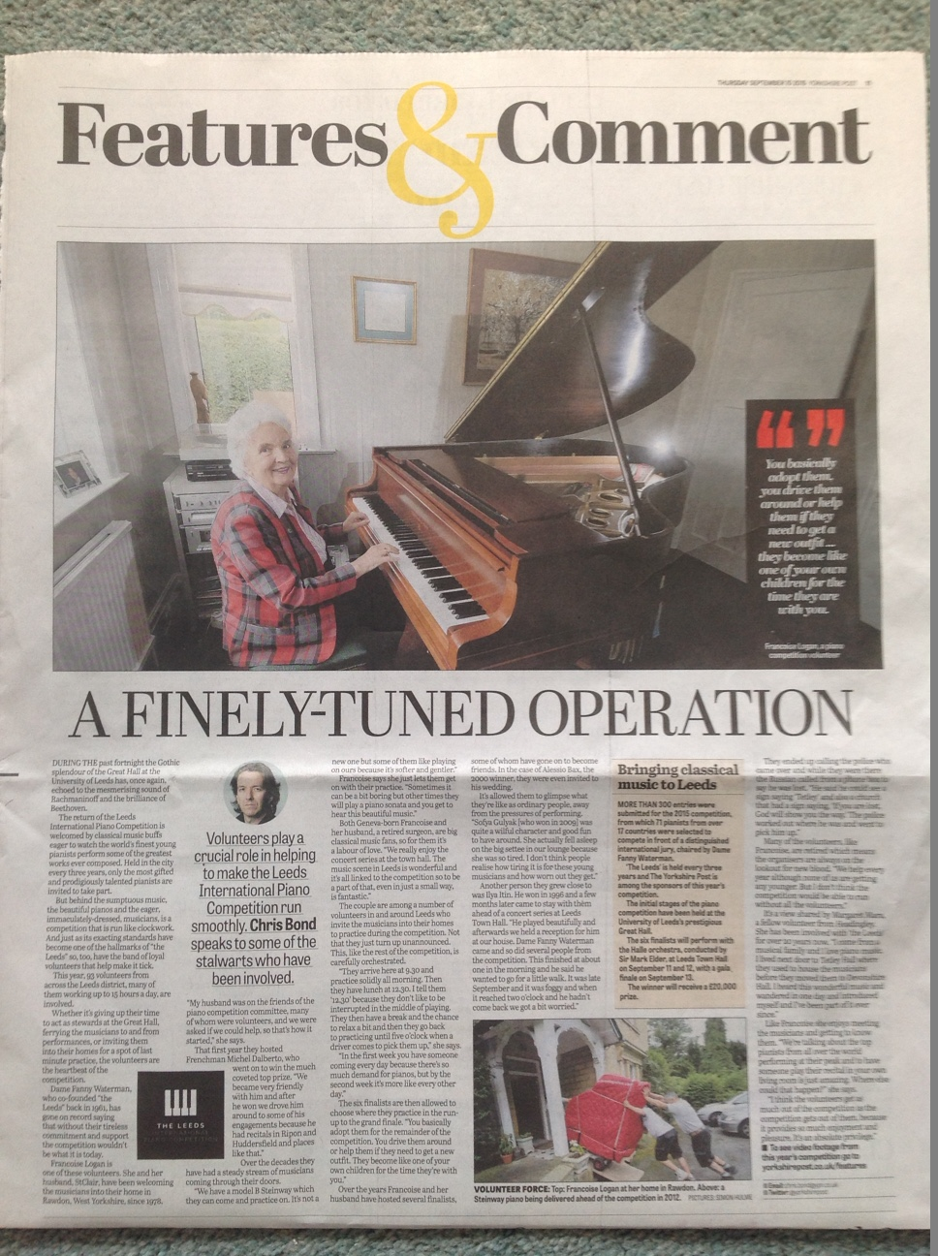
Françoise Logan
SOCIAL COMMITTEE

Several Members of the Committee again helped at the Projects Coffee morning in March, served tea at the Forest Hill Garden Party, and provided Refreshments at the afternoon talk and discussion on the problems posed by Internet Pornography, and the dangers of Grooming by Sexual Predators on Children and young People.
Our Annual Sandwich Lunch and Christmas Food Fayre, will be held on the 5th November at St. Chad’s Church Parish Centre, Headingley. There will be a Food Stall of Christmas Goodies all homemade by members of the Committee, Phoenix Cards will have a Stall, and also Handbags, Purses, Scarves. Jewellery, Books and CDs, and a Raffle. Please support this Event bring your Friends, so we can make it a success and provide a good Donation to the Charity we are supporting, Leeds Area Riding for the Disabled, this is a Charity based at Gaeton Hill Farm Barn, East Keswick.
It is a Voluntary organisation, offering Children and Young Adults with a wide range of Physical and learning difficulties the opportunity to learn to ride and enjoy Horses. Gaeton Hill Farm provides Riding Therapy for 27 Disabled Children and young Adults each weekend.
Through the years the benefit of RDA activites have become increasingly recognised by Medical and Educational Establishments as highly effective therapy which contributes to the improvement of a wide range of Medical Conditions. Riding strengthens postural support and Muscle Tone, whilst improving balance and co-ordination, it improves communication and self discipline and brings a new dimension to restricted lives, developing new skills, provides stimulating sensory experience, and encourages independence.
A Representative from the Charity will give a short presentation of the work of the Charity and the Facilities that are available.
This year we also hope to be able to give a Donation to the Awards Committee.
Gill Milner

S A N D W I C H L U N C H

Thursday 5 November 2015
11.30 am to 2.00 pm

St Chad’s Parish Centre Otley Road Far Headingley Leeds LS16 5JT

INTERNET SAFETY STUDY AFTERNOON
Safeguarding young people on the Internet and developing 'digital citizenship'
The Projects’ Committee hosted a study afternoon in July at Forest Hill when members gathered for a presentation given by Claire Dodds of Leeds City Council about the problems posed by internet pornography and the dangers of grooming by sexual predators on children and young people. It was a successful and thought provoking event and we extend our thanks to Claire Dodds and to our committee member Kathy Hart, who organised and co-ordinated the afternoon.
The Projects Committee are considering holding another such event as everyone that went felt that as parents and grandparents it was extremely useful information and advice on how to protect children. Let us know if you would be interested in attending.
Peggy Pullan

MEMBER NEWS

New Members
Dr Ann Christys
Resignations
Mrs Kirsten Greenwood
Mrs Marjory Hampton
Mrs Janet Mills
Mrs Audrey Smith

Deaths
Mrs Eileen Ellis
Mrs Virginia Rushton
Mrs Betty Vigrass OBE
Miss Margaret Pearson
Mrs Mary Hughes

Mrs Elizabeth Peacock

We were delighted to receive the following Press Release regarding member Mrs Elizabeth Peacock. Exciting times ahead, I’m sure we all wish Elizabeth good luck with her new role.

Former Yorkshire MP to Chair important Westminster Association

Elizabeth Peacock former MP for Batley and Spen [1983-1997] has been elected to serve as Chairman of the Association of Former Members of Parliament for the length of this Parliament.

The Association of Former Members has a clearly defined role to make the wide ranging experience gained by Members of Parliament during their active years available for the present government and the nation.
Through a recently established educational Trust the Association has developed an Outreach Programme to link schools, colleges and universities with Westminster to further the understanding of British parliamentary democracy .This is achieved by members of the association making visits to lead non-party political discussions, on the work of government, MP’s and the day to day running of Parliament itself.
Members from across the political spectrum are available to advise governments, especially Commonwealth governments, on aspects of democracy and the workings of an established legislature

Elizabeth Peacock said:
“It is a great honour to be elected Chairman of this organisation which has a growing importance on the Westminster scene as a point of contact for writers, researchers and the media.
My objective, together with the members of our Executive Committee, is to further extend our Outreach Programme to enhance the understanding of the work of Parliament and to ensure that the knowledge of our widely experienced members is available to those who require assistance, discussion and opinion.”

WELCOME TO OUR NEW MEMBER……..

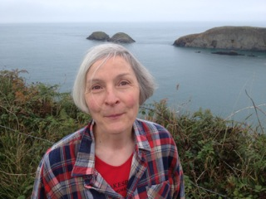

Ann Christys

“I retired recently, having worked as an anaesthetist, mainly at Leeds General Infirmary. About fifteen years ago I completed a PhD in history in Leeds and my main hobby is studying the history of Islamic Spain in the early Middle Ages. I also play in a consort of viols and enjoy listening to live classical music. Lilias Byrn introduced me to the YCLE and I am pleased to be able to contribute in a small way to the education of women who are not as fortunate in this respect as I have been.”

DATES FOR THE DIARY

Executive Committee Meetings: Monday 30 November - Annual Meeting
Projects Committee Meetings: Monday 18 January 10.00 am
Social Committee Meetings: Thursday 7 January 10.15 am
Social Committee Sandwich lunch Thursday 5 November, St Chad’s Parish Centre 11.30 am
Annual General Meeting Monday 1 February

